
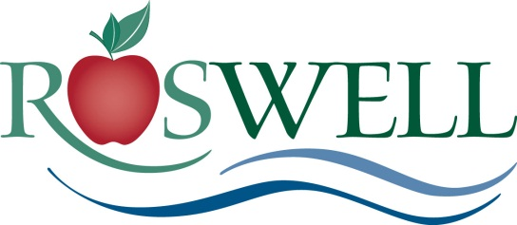
Name:
Department:
Contact Number:
E-mail Address:
Home City, Zip | , Georgia *Needed to process check request only
Quarter (select one) | □ Sept-Nov | □ Dec-Feb | □ Mar-May | □ Jun-Aug | Year: 2021

The City of Roswell wants employees to achieve a healthier lifestyle with exercise. The City of Roswell will reimburse employees up to $15 a quarter towards their membership to BJCAB.

In order to receive reimbursement, the employee must:
- Register and pay through the Rec and Park Department located on the 1st floor at City Hall.
- Pay the $5 monthly fee. (There is no prorating of this fee.)
- Workout and sign-in at the BJCAB Fitness Center at least 1x each month. (Please put COR beside your name.)
- The employee must submit this reimbursement form to HR within 10 days of the last day in the last month in the quarter.

Quarters: Months: Form due to HR by:
Fall September – November December 10
Winter December – February March 10
Spring March – May June 10
Summer June – August September 10

________________________________________________________________________________________
For the Employee:
I certify that I paid and was actively participating at the BJCAB for the quarter that I am requesting reimbursement. I understand that falsifying this document may result in disciplinary action up to and including termination.

________________________________ Click or tap to enter a date.
Signature Date

