City of Roswell’s

CORE Program
2024 - 2025

You don’t just work here; you belong here!

 | Winter, 2024 – 2025

The CORE program (City of Roswell Education and Engagement) allows employees to gain a comprehensive understanding of the various departments and dimensions of working at the City. By participating in this program, employees will:

- Learn more about the City of Roswell.
- Understand the workplace culture.
- Meet colleagues from different departments.

This hands-on program includes a tour of the facilities, offering valuable insights into City operations.

Date | Time | Departments/Locations
January 10 | 8:00 AM – 12:00 PM | Finance and City Hall
January 17 | 8:00 AM – 12:00 PM | Fire and Police at RAPSTC
January 24 | 8:00 AM – 12:00 PM | Transportation and Environmental/Public Works
February 7 | 8:00 AM – 12:00 PM | Bus Tour of Roswell Parks (R&P)

NOTE - The CORE Program will also be offered:
March-April, 2025
Eligibility:
- Approval from the Department Director and Supervisor is required to participate in the program.
Application Procedure:
Interested employees must submit their application to Maggie Menkus, Education Coordinator in Human Resources, no later than Monday, December 9, 2024. The application must include signatures from both the Department Director and the Supervisor.
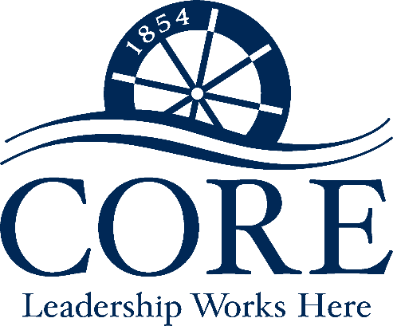
City of Roswell’s
CORE Program 2024 - 2025

First Name: |  | Last Name:

Department: | Department | Current Position:

Date of Hire: | ___/____/______ | Date in Current Position: | ___/____/______

Supervisor: |  | Department Director:

By applying to the CORE Program, you are agreeing to attend and participate in the scheduled sessions below:

Date | Time | Departments/Locations
January 10 | 8:00 AM – 12:00 PM | Finance and City Hall
January 17 | 8:00 AM – 12:00 PM | Fire and Police at RAPSTC
January 24 | 8:00 AM – 12:00 PM | Transportation and Environmental/Public Works
February 7 | 8:00 AM – 12:00 PM | Bus Tour of Roswell Parks (R&P)

Submit your application to Maggie Menkus, Education Coordinator in Human Resources, by Monday, December 9, 2024. Only applications with the required approval signatures will be accepted.

I want to be considered for the City of Roswell’s CORE Program. I understand that I will be required to attend the above-mentioned scheduled sessions. I have received my Department Director’s and Supervisor’s approval to apply, as indicated below by their signature.

Signature: |  |  |  |  | Date:
Mgr/Supv. Signature: |  |  |  |  |  | Date:
Dept. Director Signature: |  |  |  |  |  |  | Date:

