No Equipment Workouts

Cinch – Squeeze the abdominal muscles as you would if you were guarding your stomach from a punch. Hold for 30 seconds.

Glutes – Squeeze the muscles in your buttocks. Hold for 30 seconds.

Shoulder Squeeze – With elbows bent, squeeze the shoulder blades together. Hold for 30 seconds.
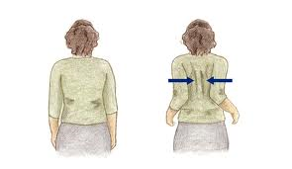Demonstration of Shoulder Squeeze

Transverse Abs – Cinch your lower abs as you would if you were zippering tight pants. Hold for 30 seconds.

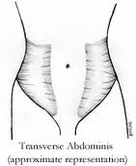 Location of your Transverse Abs
Dead Lift – With knees slightly bent and back straight, arms straight and slightly in front of your thighs (make a fist like you’re holding a barbell), hinge at the waist and then stand straight back up while cinching the abs and glutes. Repeat for 3 sets of 15 reps. This can also be done on one leg.
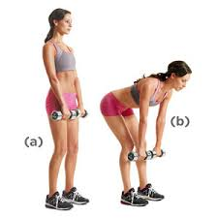Demonstration of Dead Lift form (no weights needed)

Rows – With knees slightly bent, abs cinched and waist hinged at about 45 degrees, and elbows at 90 degrees by your side move arms forward and then back into shoulder squeeze. Repeat for 3 sets of 15 reps.
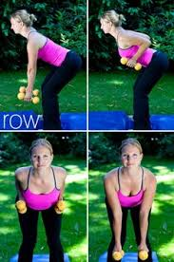 Demonstration of Rows (no weights needed)

Mountain Climbers – In plank position (hands under shoulders, feet extended behind you), cinch abs and slowly alternate feet from extended position to under your buttocks. Do not bounce or jump. Alternate 30 times. Alternately, you can hold in plank position (knees on ground or on balls of your feet) for 30 seconds.
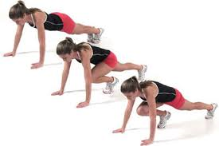 Demonstration of Mountain Climbers
Plank Position

Stick Ups – Stand against the wall, knees slightly bent, with your elbows at 90 degrees; hands, elbows, shoulders, small back and buttocks should be pressed against the wall. Cinch your transverse abs to help push the small of your back into the wall. Slowly push your hands up towards each other, keeping your arms pressed against the wall, and feel your shoulders stretch.
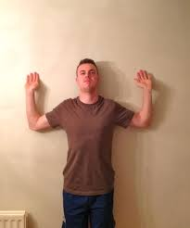 Demonstration of Stick Up Position

Knee-to-Elbow – Lift left knee and bring towards right elbow; alternate with right knee to left leg. Repeat for 30 seconds.
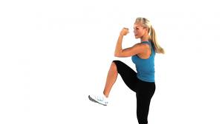Demonstration of Knee to Elbow

Wall Push-Ups – Place your hands on the wall directly in front of your shoulders. Extend your feet out behind you, shoulder width apart, so that your body is about a 30 degree angle from the wall. Press your chest towards your hands, keeping your elbows by your side. Repeat 3 sets of 15.
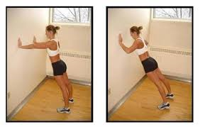

Arm Supination – Extend arms straight out to the side, palms facing down, at 90 degrees to your body. Slowly rotate your palms back until they are facing up towards the ceiling (supination). Feel your chest open up and stretch. Hold for 10 seconds. Repeat.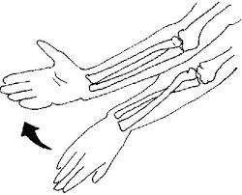Demonstration of Supination of the Forearm
Bent Over Hamstring Stretch – Place your hands high up on your thighs just below where your legs join your hips; bend your knees slightly. Hinge at the waist until you are fully bent over. Cinch your transverse abs and push them towards the back so that your buttocks pushes up and out. You will feel the stretch in your hamstrings. Hold for 10 seconds.
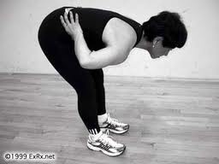 Demonstration of Hamstring Stretch

